Apoorvaa has created an elevated roof. She wants to know how much water can she save during rain.

Given n non negative integers representing the elevation map where width of every bar is 1, Find the maximum water that she can save.

Explanation for the Sample input Testcase:  
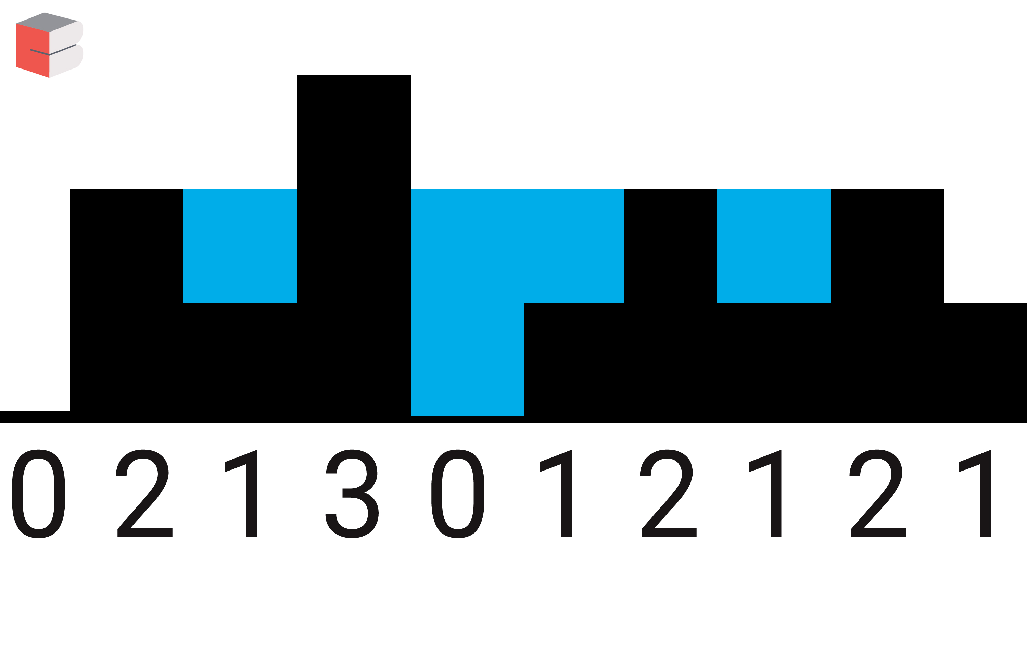

So the total units of water she can save is 5 units

**Input Format**

First line contains an integer n. Second line contains n space separated integers representing the elevation map.

**Constraints**

**Output Format**

Print a single integer containing the maximum unit of waters she can save.

**Sample Input**

10

0 2 1 3 0 1 2 1 2 1

**Sample Output**

5

**Program-**

#include<iostream>

using namespace std;

int main()

{

int n,i,count=0;

cin>>n;

int *a=new int[n];

for(i=0;i<n;i++)

{

cin>>a[i];

}

int *left=new int[n];

int *right=new int[n];

left[0]=a[0];

for(i=1;i<n;i++)

{

left[i]=max(a[i],left[i-1]);

}

right[n-1]=a[n-1];

for(i=n-2;i>=0;i--)

{

right[i]=max(a[i],right[i+1]);

}

for(i=0;i<n;i++)

{

count=count+(min(left[i],right[i])-a[i]);

}

cout<<count<<endl;

}